**Assignment -3**

**Cloud object storage and Watson assistant**

|  |  |
| --- | --- |
| **Date** | **17 November 2022** |
| **Team ID** | **PNT2022TMID46949** |
| **Project Name** | **Project-Inventory Management System For Retailers** |
| **Maximum Marks** | **2 Marks** |

**Question-1:**

**Create a Bucket in IBM object storage**

**Solution:**

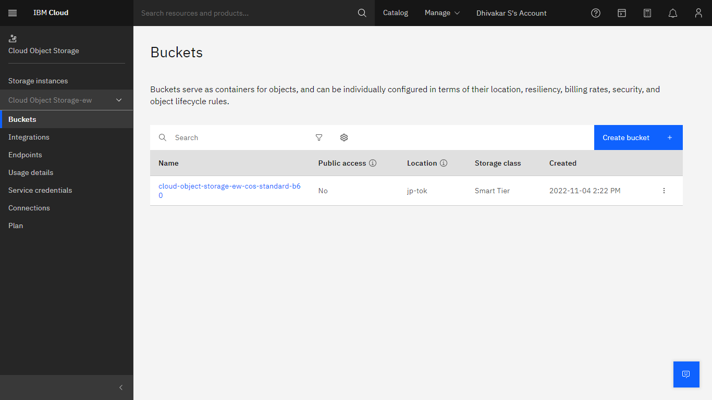

**Question-2:**

**Upload an 5 images to ibm object storage and make it public. Write html code to displaying all the 5 images.**

**Solution:**

**Html code:-**

<!DOCTYPE html>

<html>

<head>

<link rel="stylesheet" href="https://cloud-object-storage-er-cos-standard-1xw.s3.jp-tok.cloud-object-storage.appdomain.cloud/new.css">

</head>

<body>

<h1>This images are from the cloud object storage</h1>

<div class="grid-container">

<div class="item1"><img src="https://cloud-object-storage-er-cos-standard-1xw.s3.jp-tok.cloud-object-storage.appdomain.cloud/1.jpg" alt="Girl in a jacket"></div>

<div class="item2"><img src="https://cloud-object-storage-er-cos-standard-1xw.s3.jp-tok.cloud-object-storage.appdomain.cloud/2.jpg" alt="Girl in a jacket"></div>

<div class="item3"><img src="https://cloud-object-storage-er-cos-standard-1xw.s3.jp-tok.cloud-object-storage.appdomain.cloud/3.jpg" alt="Girl in a jacket"></div>

<div class="item4"><img src="https://cloud-object-storage-er-cos-standard-1xw.s3.jp-tok.cloud-object-storage.appdomain.cloud/4.jpg" alt="Girl in a jacket"></div>

<div class="item5"><img src="https://cloud-object-storage-er-cos-standard-1xw.s3.jp-tok.cloud-object-storage.appdomain.cloud/5.jpg" alt="Girl in a jacket"></div>

</div>

</body>

</html>

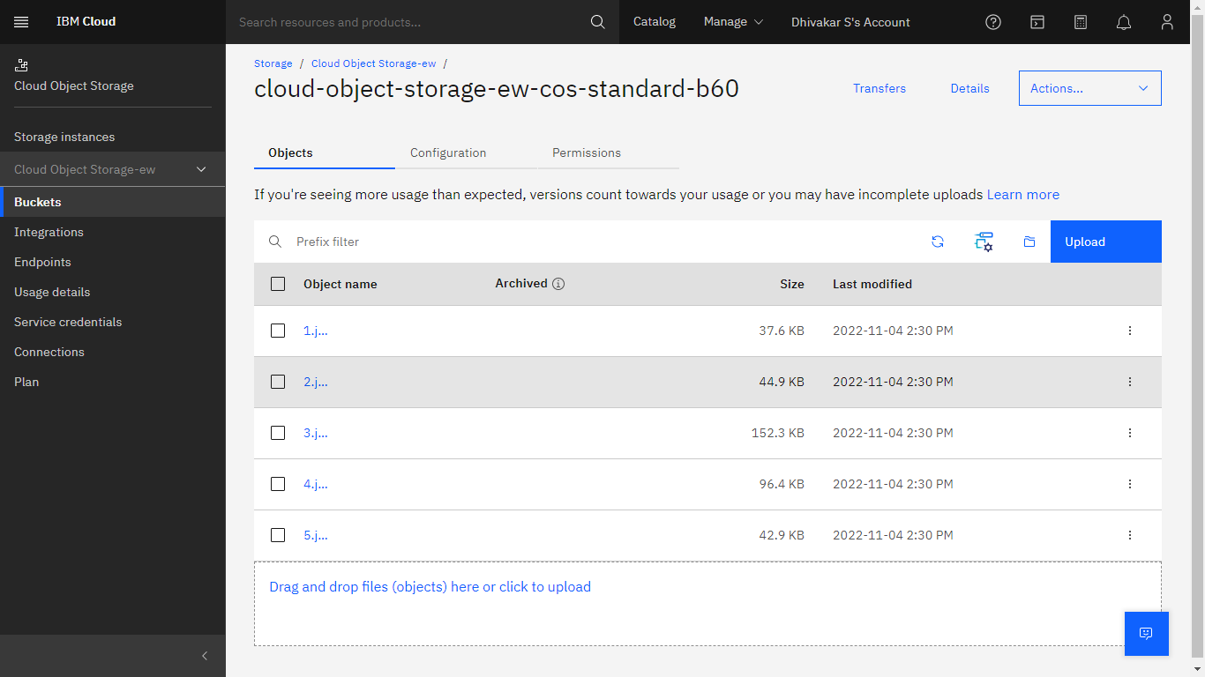

**Question-3:**

**Upload a css page to the object storage and use the same page in your html code.**

**Solution:**

New.css uploaded to the object storage and used the same page in html



Css page used in html page

**Question-4:**

**Design a Chabot using IBM Watson assistant for hospital. Ex: User come the query to know the braches for that hospital in your city.**

**Solution:**

URL for: <https://web-chat.global.assistant.watson.appdomain.cloud/preview.html?backgroundImageURL=https%3A%2F%2Fau-syd.assistant.watson.cloud.ibm.com%2Fpublic%2Fimages%2Fupx-0516420a-a54c-4626-b459-481c71f5ac41%3A%3A512d2748-7659-4d70-ba79-81fcedac9d3b&integrationID=0b305951-d464-4f72-9cc7-938932287427&region=au-syd&serviceInstanceID=0516420a-a54c-4626-b459-481c71f5ac41>

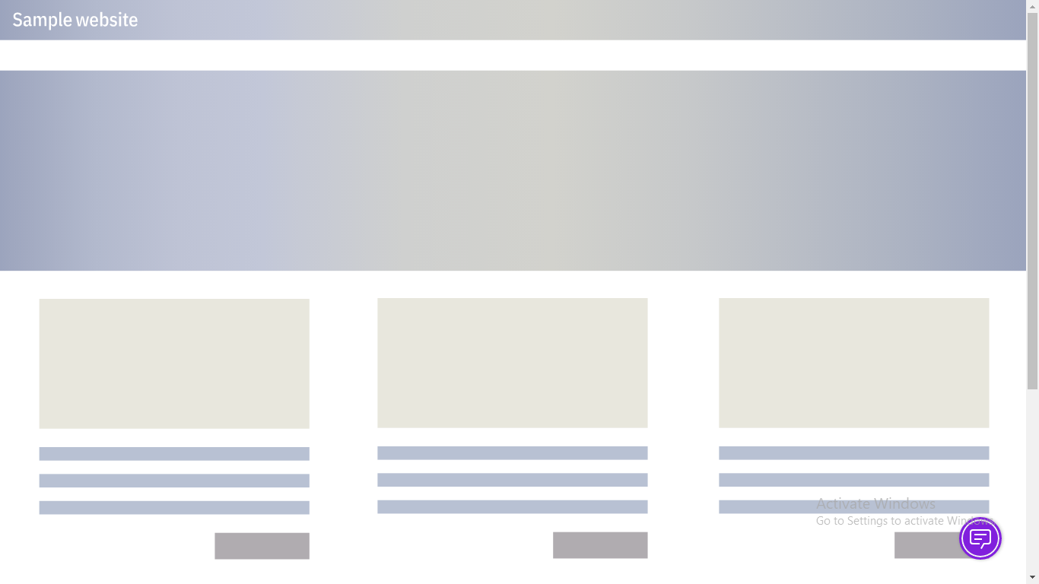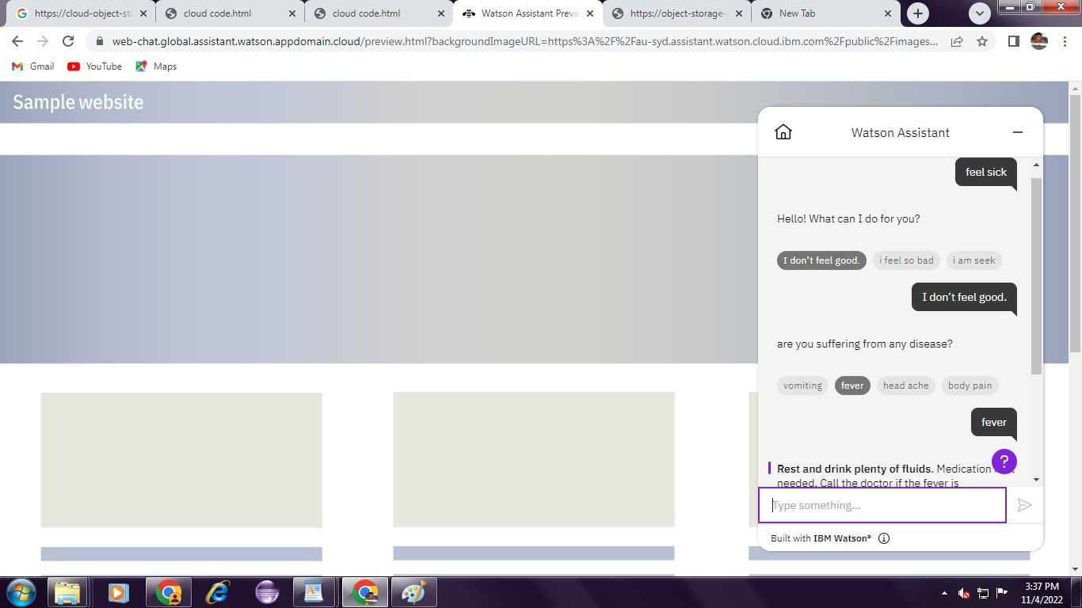

**Question-5:**

**Create Watson assistant service with 10 steps and use 3 conditions in it. Load that script in html page**

**Solution:**

<!DOCTYPE html>

<html>

<head>

<link rel="stylesheet" href="https://cloud-object-storage-ew-cos-standard-b60.s3.jp-tok.cloud-object-storage.appdomain.cloud/new.css">

</head>

<script>

window.watsonAssistantChatOptions = {

integrationID: "0b305951-d464-4f72-9cc7-938932287427", // The ID of this integration.

region: "au-syd", // The region your integration is hosted in.

serviceInstanceID: "0516420a-a54c-4626-b459-481c71f5ac41", // The ID of your service instance.

onLoad: function(instance) { instance.render(); }

};

setTimeout(function(){

const t=document.createElement('script');

t.src="https://web-chat.global.assistant.watson.appdomain.cloud/versions/" + (window.watsonAssistantChatOptions.clientVersion || 'latest') + "/WatsonAssistantChatEntry.js";

document.head.appendChild(t);

});

</script>

<body>

<h1>This images are from the cloud object storage</h1>

<div class="grid-container">

<div class="item1"><img src="cos://jp-tok/cloud-object-storage-ew-cos-standard-b60/1.jpg" alt="Item 1"></div>

<div class="item2"><img src="cos://jp-tok/cloud-object-storage-ew-cos-standard-b60/2.jpg" alt="Item 2"></div>

<div class="item3"><img src="cos://jp-tok/cloud-object-storage-ew-cos-standard-b60/3.jpg" alt="Item 3"></div>

<div class="item4"><img src="cos://jp-tok/cloud-object-storage-ew-cos-standard-b60/4.jpg" alt="Item 4"></div>

<div class="item5"><img src="cos://jp-tok/cloud-object-storage-ew-cos-standard-b60/5.jpg" alt="Item 5"></div>

</div>

</body>

</html>

**Output:**

URL for chatbot: [https://web-chat.global.assistant.watson.appdomain.cloud/preview.html?backgroundImageURL=https%3A%2F%2Fau-syd.assistant.watson.cloud.ibm.com%2Fpublic%2Fimages%2Fupx-0516420a-a54c-4626-b459-481c71f5ac41%3A%3A512d2748-7659-4d70-ba79-81fcedac9d3bHYPERLINK "https://web-chat.global.assistant.watson.appdomain.cloud/preview.html?backgroundImageURL=https%3A%2F%2Fau-syd.assistant.watson.cloud.ibm.com%2Fpublic%2Fimages%2Fupx-0516420a-a54c-4626-b459-481c71f5ac41%3A%3A512d2748-7659-4d70-ba79-81fcedac9d3b&integrationID=0b305951-d464-4f72-9cc7-938932287427&region=au-syd&serviceInstanceID=0516420a-a54c-4626-b459-481c71f5ac41"&HYPERLINK "https://web-chat.global.assistant.watson.appdomain.cloud/preview.html?backgroundImageURL=https%3A%2F%2Fau-syd.assistant.watson.cloud.ibm.com%2Fpublic%2Fimages%2Fupx-0516420a-a54c-4626-b459-481c71f5ac41%3A%3A512d2748-7659-4d70-ba79-81fcedac9d3b&integrationID=0b305951-d464-4f72-9cc7-938932287427&region=au-syd&serviceInstanceID=0516420a-a54c-4626-b459-481c71f5ac41"integrationID=0b305951-d464-4f72-9cc7-938932287427HYPERLINK "https://web-chat.global.assistant.watson.appdomain.cloud/preview.html?backgroundImageURL=https%3A%2F%2Fau-syd.assistant.watson.cloud.ibm.com%2Fpublic%2Fimages%2Fupx-0516420a-a54c-4626-b459-481c71f5ac41%3A%3A512d2748-7659-4d70-ba79-81fcedac9d3b&integrationID=0b305951-d464-4f72-9cc7-938932287427&region=au-syd&serviceInstanceID=0516420a-a54c-4626-b459-481c71f5ac41"&HYPERLINK "https://web-chat.global.assistant.watson.appdomain.cloud/preview.html?backgroundImageURL=https%3A%2F%2Fau-syd.assistant.watson.cloud.ibm.com%2Fpublic%2Fimages%2Fupx-0516420a-a54c-4626-b459-481c71f5ac41%3A%3A512d2748-7659-4d70-ba79-81fcedac9d3b&integrationID=0b305951-d464-4f72-9cc7-938932287427&region=au-syd&serviceInstanceID=0516420a-a54c-4626-b459-481c71f5ac41"region=au-sydHYPERLINK "https://web-chat.global.assistant.watson.appdomain.cloud/preview.html?backgroundImageURL=https%3A%2F%2Fau-syd.assistant.watson.cloud.ibm.com%2Fpublic%2Fimages%2Fupx-0516420a-a54c-4626-b459-481c71f5ac41%3A%3A512d2748-7659-4d70-ba79-81fcedac9d3b&integrationID=0b305951-d464-4f72-9cc7-938932287427&region=au-syd&serviceInstanceID=0516420a-a54c-4626-b459-481c71f5ac41"&HYPERLINK "https://web-chat.global.assistant.watson.appdomain.cloud/preview.html?backgroundImageURL=https%3A%2F%2Fau-syd.assistant.watson.cloud.ibm.com%2Fpublic%2Fimages%2Fupx-0516420a-a54c-4626-b459-481c71f5ac41%3A%3A512d2748-7659-4d70-ba79-81fcedac9d3b&integrationID=0b305951-d464-4f72-9cc7-938932287427&region=au-syd&serviceInstanceID=0516420a-a54c-4626-b459-481c71f5ac41"serviceInstanceID=0516420a-a54c-4626-b459-481c71f5ac41](https://web-chat.global.assistant.watson.appdomain.cloud/preview.html?backgroundImageURL=https%3A%2F%2Fau-syd.assistant.watson.cloud.ibm.com%2Fpublic%2Fimages%2Fupx-0516420a-a54c-4626-b459-481c71f5ac41%3A%3A512d2748-7659-4d70-ba79-81fcedac9d3b&integrationID=0b305951-d464-4f72-9cc7-938932287427&region=au-syd&serviceInstanceID=0516420a-a54c-4626-b459-481c71f5ac41)